Network Project

Network Design for small Airport.

**Introduction:**

Firstly, The Virtual local area network will be used in order to divide the whole airport area into 3 logical segments instead of physical in which each will represent a whole department within the airport. Each department will have its own encapsulation by mapping its own IP address and this will be done by configuring the router in to 3 sections in which each will represent a department within the airport. The restrictions will be applied by the main Router that connects the entire departments with a high-speed internet connection. One which is the flight service providers should have access only to the specific server that handles flight management control in the airport authority network and not to any other systems and the Other that the guest users should not have access to the other department. Finally, all of the users in different department will be gained an IP address automatically and this will be done by an DHCP server.

Three department means 3 VLAN in which each department will be mapped to one and the membership will be based on the IP address for each of the VLANs.

* VLAN 2🡪 Airport Authority.
* VLAN 3🡪 Flight Service Providers.
* VLAN 4🡪 The Guests.

Each will have its own encapsulation and taking own private IP addresses in specific range

* VLAN 2🡪 192.168.2.0
* VLAN 3🡪 192.168.3.0
* VLAN 4🡪 192.168.4.0

The first and the last address will be reserved for the network address that specifies each department in the airport so each will start from 192.168.2.1-192.168.2.254 the same applied for the all VLANs.

**Requirement and methodology:**

Active networking components (Routers, Switches, Wireless Access Points…etc.) with quantity

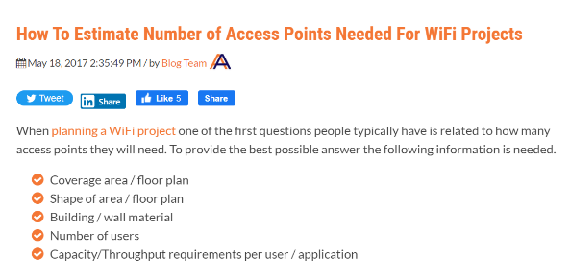1-Switches: we used in our design 3 switches since the airport topology is made up of 3 departments in which the first is Airport Authority that is made of 20 users (20 port) is required, Flight and service providers that consist of 40 users (40 port) which indicate having in the Airport Lan 60 user each should be connected which port and guests that are estimated to 100 guest that are connected using 3 access points since one of the criteria to estimate the number of access points required will be based on the number of users and how the load will be shared in between (3 ports) and two servers one of the server we will use it in order to handle the flight management control and the other that will be used in order to assign dynamically IP addresses instead of using the router for this (2ports) that indicates using 65 port and in each switch we have 24 port = 3 switches

2-Router: only one router is required to provide access to a high-speed internet connection that would be shared among all the users. And as well it will be used for access restriction as well as for the internet sharing.

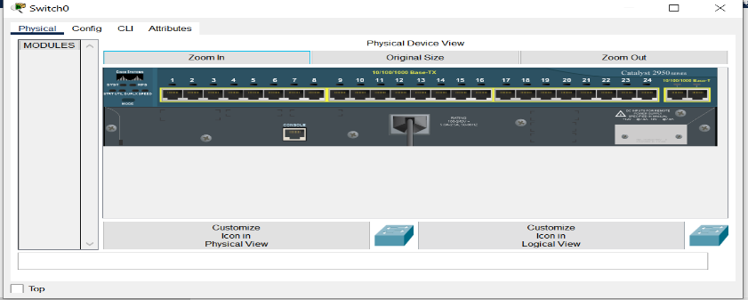3-Access-points: they are used to provide connection wirelessly for the users to be part of the airport network and 3 are required as we say based on the load shared between guests since they are estimated to 100

4-DHCP server and the other one: the DHCP server is a main component that provides the IP address to be automatically assigned for the users within the network airport.



5-The devices as specified in the packet tracer the VLAN2 by the PCs, VLAN3 by the Laptops and VLAN4 specified by wireless devices that are connected by the Access points.

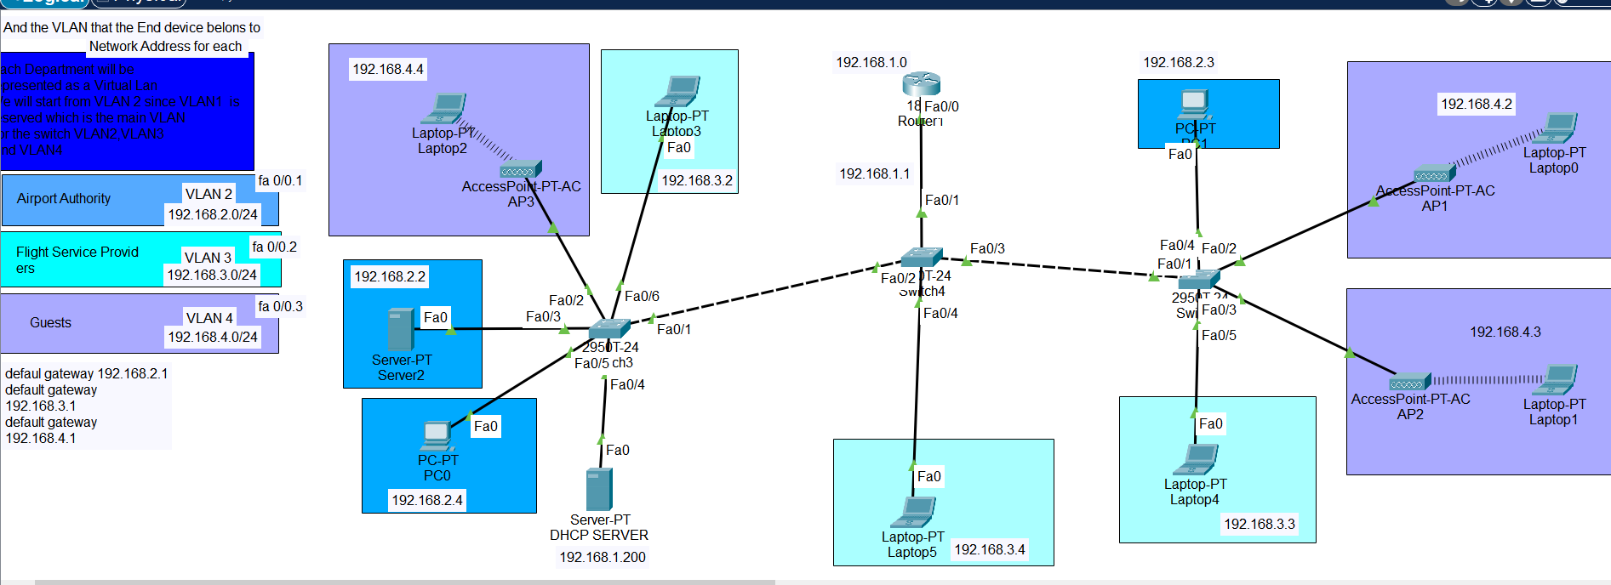**Simulation and Design: **

**Discussion and Analysis:**

1-Firstly, we start by the Access points that later will be assigned automatically assigned to the DHCP server. For each Laptop connected with an Access point such as Laptop0, Laptop1, Laptop2 we add module WPC300N or it is called the Wireless-N Notebook Adapter which is the simple way to add or upgrade a wireless connectivity in your notebook computer and it will be applied for the above 3 laptops.

* 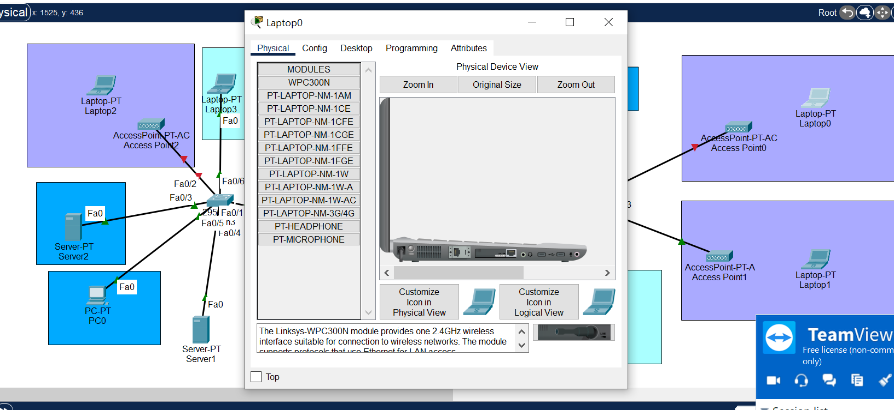Power Off the Laptop.
* Remove the Ethernet module.
* 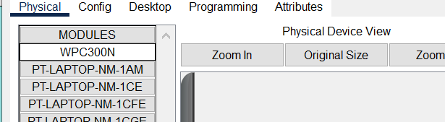Add the WPC300N or the Wireless-N adapter.

Then for each Access point Applied for the all-Access Points.

* the name was updated as well
* We set the bandwidth and the Duplex to be Auto at **port 0**
* 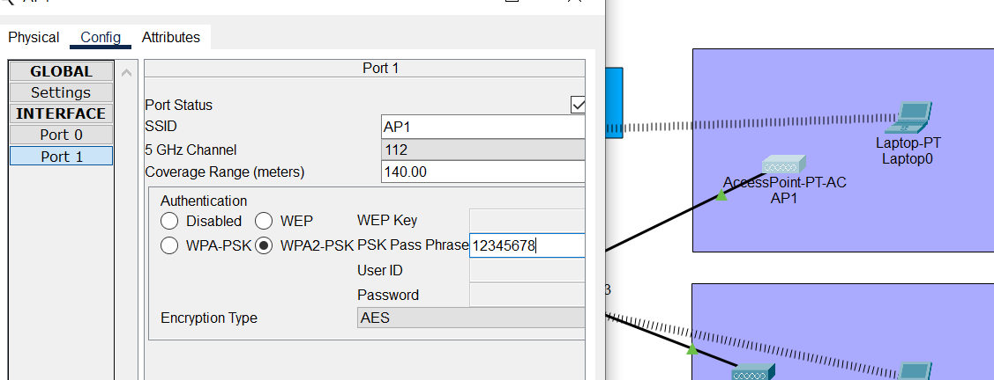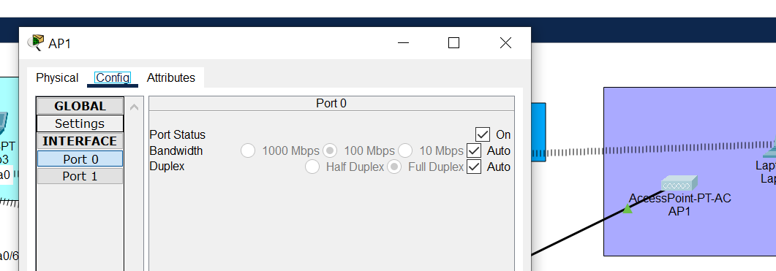At **port 1** we change the SSID as the name and add authentication to be WPA2-PSK PSK PASS PHRASE and add the password and it was notices that after all the laptops 0,1 and 2 were disconnected from All the Access points because of the added Authentication.

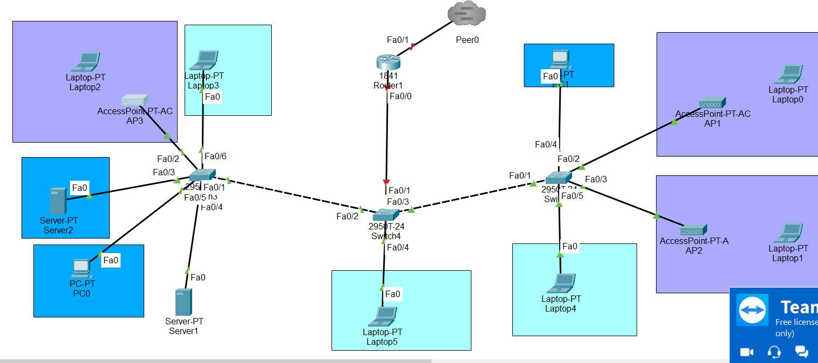2- Connecting the Laptops with APs: As we say that After Adding the Authentication was noticed that all the laptops will be disconnected from any Access point which means there is no Access to the internet and the Guests are not a part form The Lan

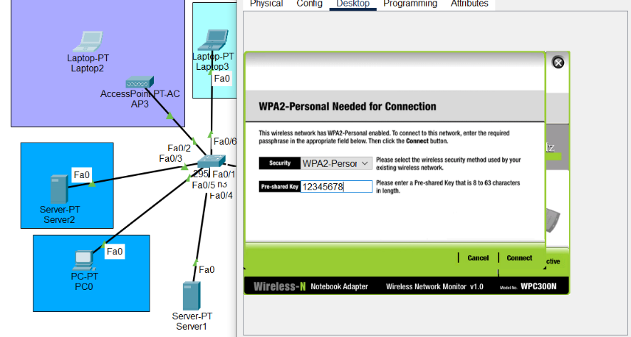This was solved by connecting each Laptop to the Appropriate Access point AP1, AP2 or AP3 and add the authentication in order to ensure on the connectivity. From Desktop – Pc Wireless.

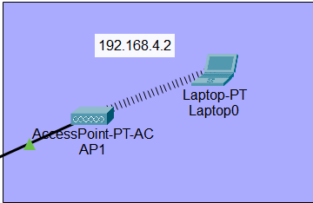

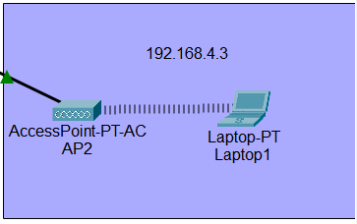

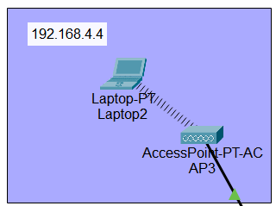

192.168.1.0 -> network IP

192.168.1.1 -> Default Gateway

3-DHCP configuration:

* change the name to the DHCP server.
* Set the DHCP services ON.
* 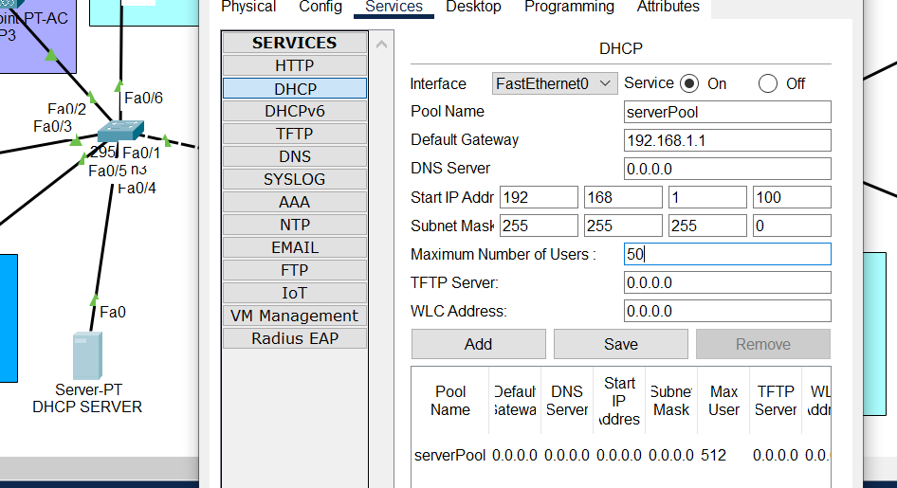Set Default gateway will be 192.168.1.1, the start Ip 192.168.1.100 and max number of devices to be 50 set any number.

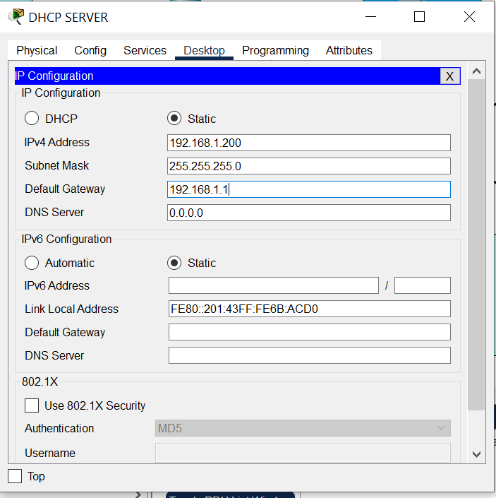Since the DHCP is responsible for assigning IP addresses and won’t assign an IP address for itself so we will assign it statically. DHCP -> DESKTOP-> IP CONFIGRATION

* ipv4 192.168.1.200
* subnet 255.255.255.0
* gateway 192.168.1.1

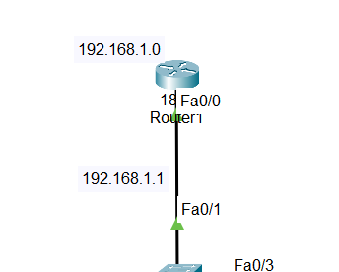4-Configure the Interface 0/0 by the Router:

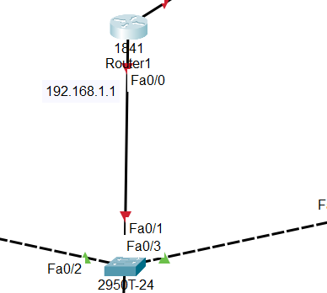

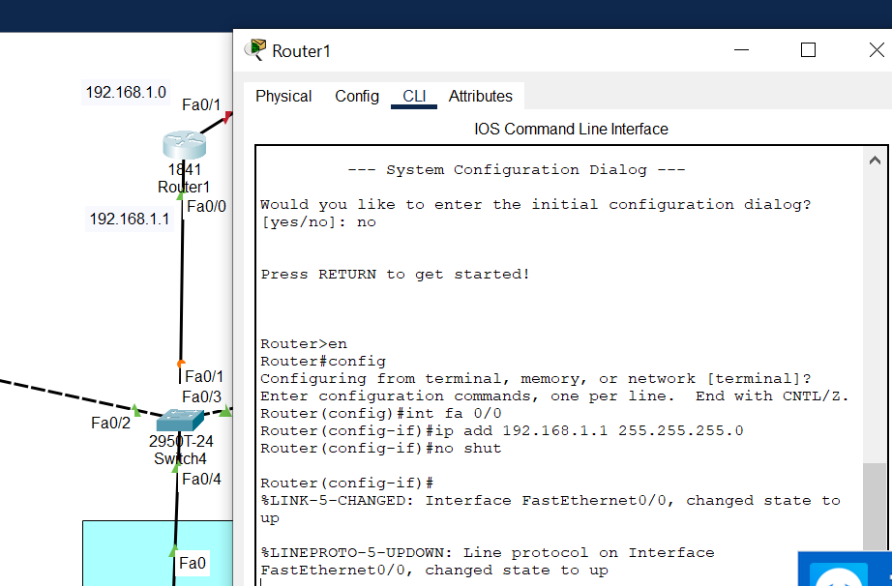

* int fa0/0
* ip add 192.168.1.1 255.255.255.0
* no shut
* copy ru st

5- Switch Configuration: To separate each switch we will use the switch in order to create the VLAN Database and will be applied for all the switches for each switch to know the number of vlans to be able to map in case of connection.

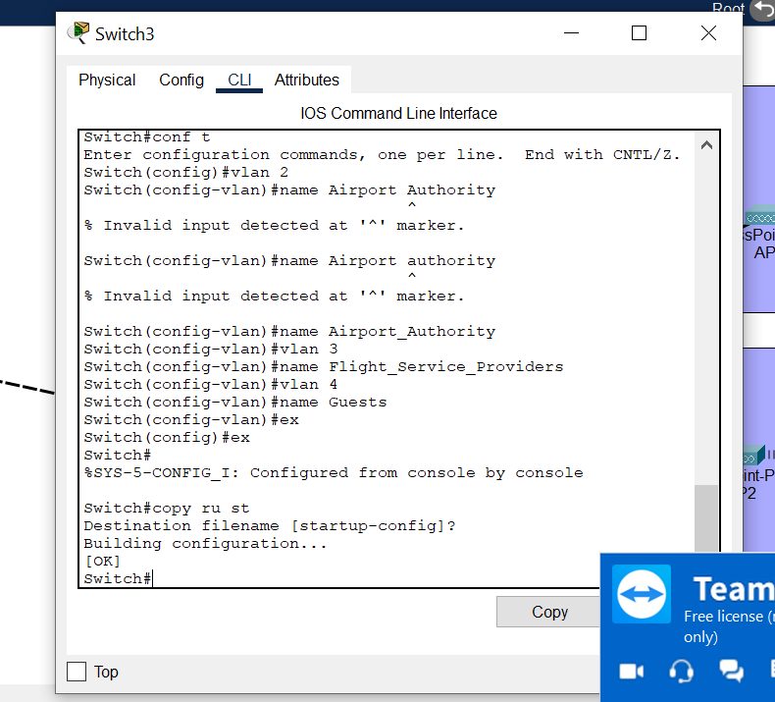Switch 3,2,1

* enable
* conf t
* vlan 2
* name Airport_Authority
* vlan 3
* name Flight_Service_providers
* vlan 4
* name Guests
* exit twice
* 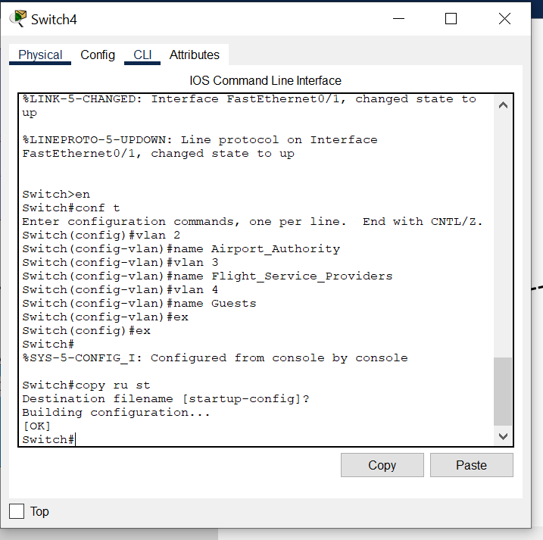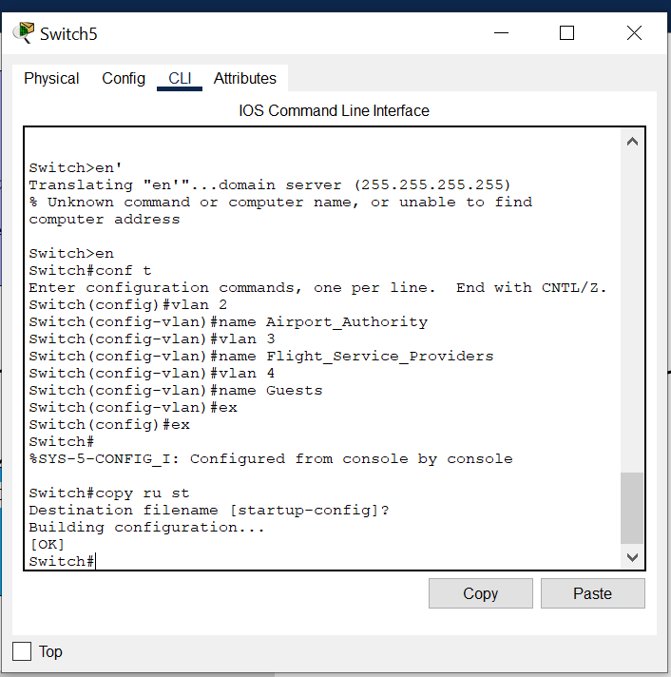Copy ru st

6-Router Configuration:

Sub interfaces on the router on the physical interface fastethernet 0/0 will be mapped into the VLANs and the IP address that is configured on the router by specifying the default gateway. We will configure the router so that the fa0/0 will be divided to get connection from 3 VLANs in which each will get its own encapsulation.

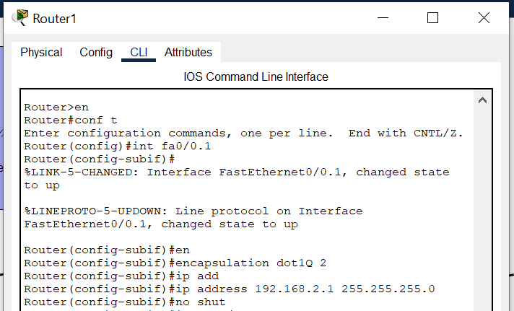A-

* enable
* conf t
* int fa0/0.1
* encapsulation dot1Q 2
* ipp addr 192.168.2.1 255.255.255.0
* no shut

B-

* enable
* conf t
* int fa0/0.2
* encapsulation dot1Q 3
* 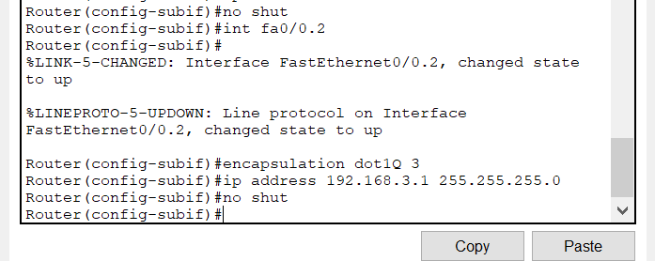ipp addr 192.168.3.1 255.255.255.0
* no shut

C-

* enable
* conf t
* int fa0/0.3
* encapsulation dot1Q 4
* ipp addr 192.168.4.1 255.255.255.0
* no shut
* exit
* exit
* copy ru st

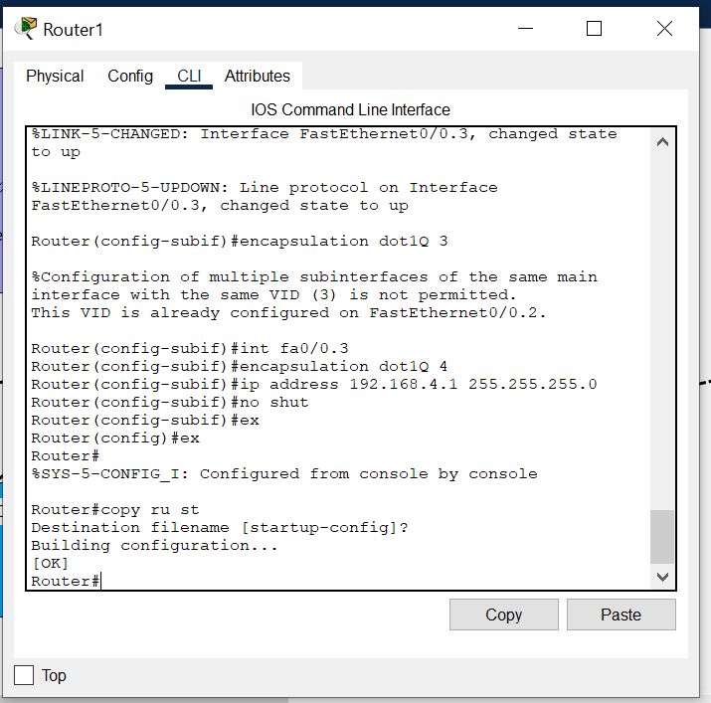

7-The DHCP configuration: for the DHCP to be able to assign IP addresses based on VLAN that the devices belong to we will create for each VLAN pool that specify the IP address, Default Gateway, numbers of devices and other information.

Let the DHCP know that there is 3 VLANs so we will create 3 POOLS each for VLAN

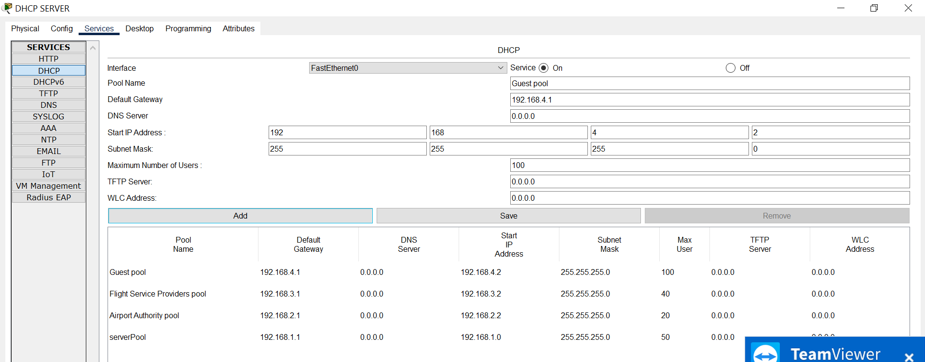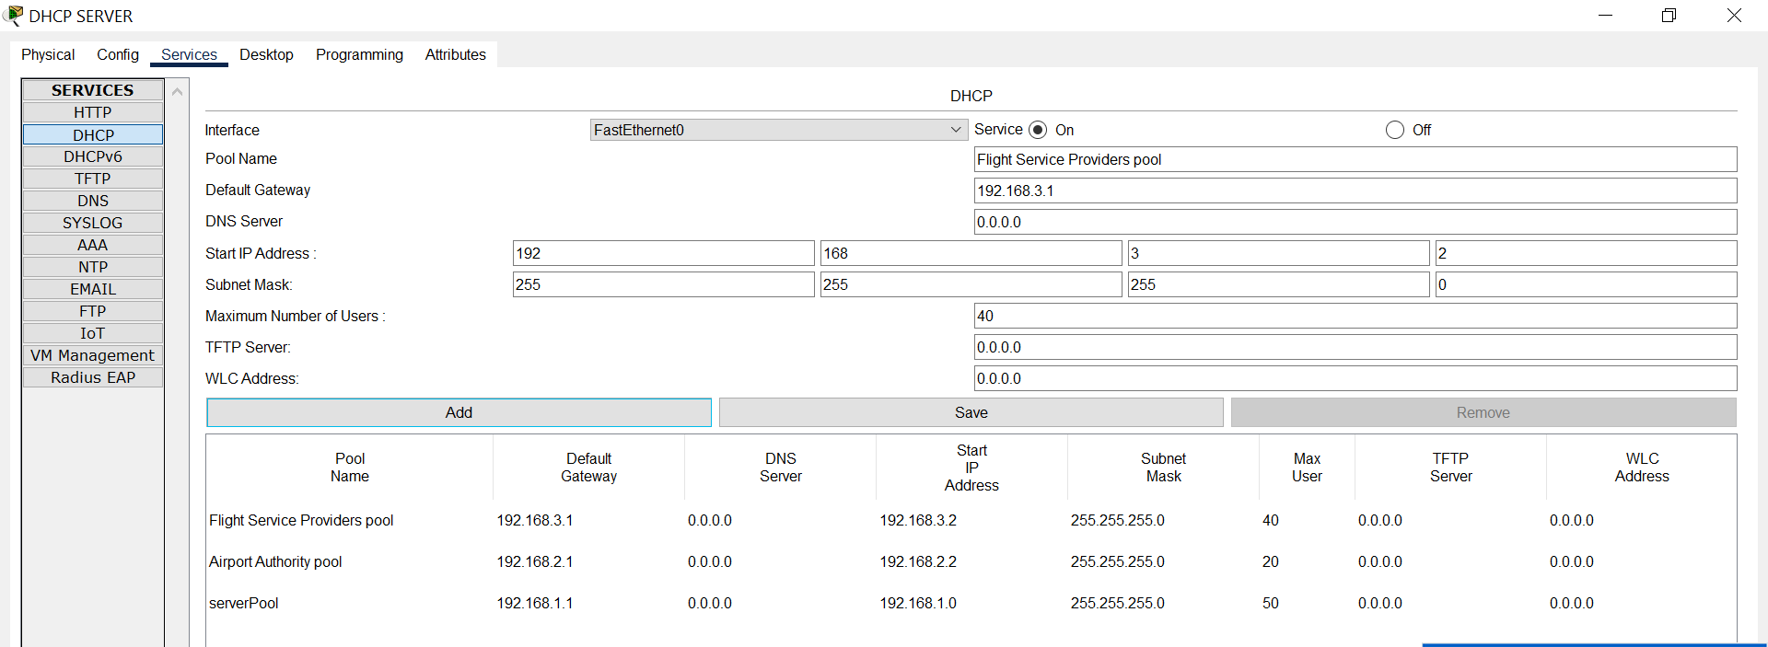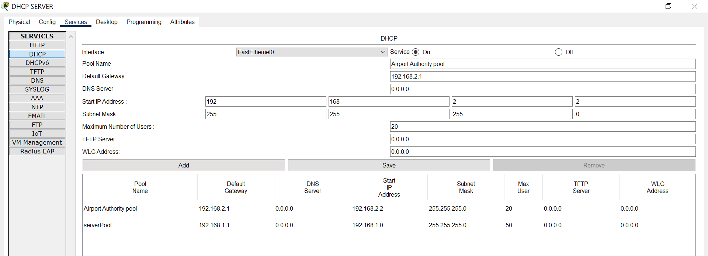A-Airport Authority Pool B-Flight Service Providers Pool C-Guests Pool



8-The IP Helper: it will be used to give each VLAN IP. We will use the IP helper. That will be configured on the VLAN 2, VLAN 3 and VLAN 4. By the interfaces of the router. The DHCP router is not part of any LANS so it has to configure the all VLANS to assign dynamic addresses and its IP address is 192.168.1.200

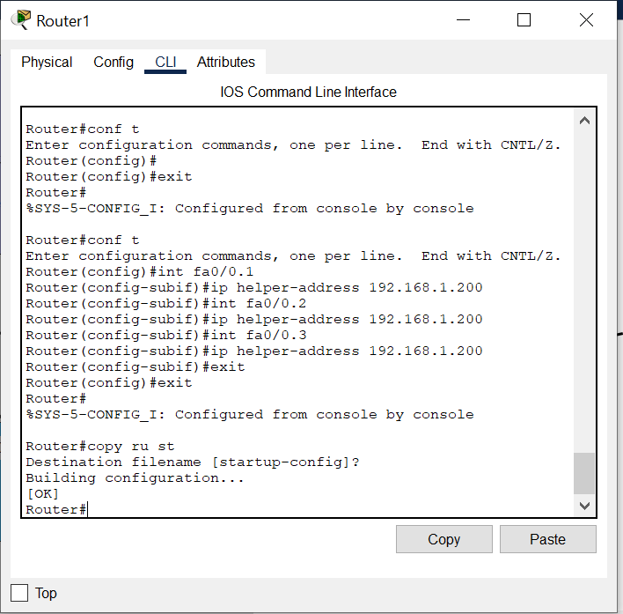We want to tell Router that DHCP will assign IP addresses for each VLAN separately by using the IP helper based on the sub interfaces.

* enable
* conf t
* int fa0/0.1
* ip helper-address 192.168.1.200
* int fa0/0.2
* ip helper-address 192.168.1.200
* int fa0/0.3
* ip helper-address 192.168.1.200
* exit
* exit
* copy ru st

9- The ACL will be done on the router #We can use the extended not the standard which means that we are allowed to use extended 100-199 the others are reserved.

A-flight service providers should have access only to the specific server that handles flight management control in the airport authority network not to any other systems. B POINT

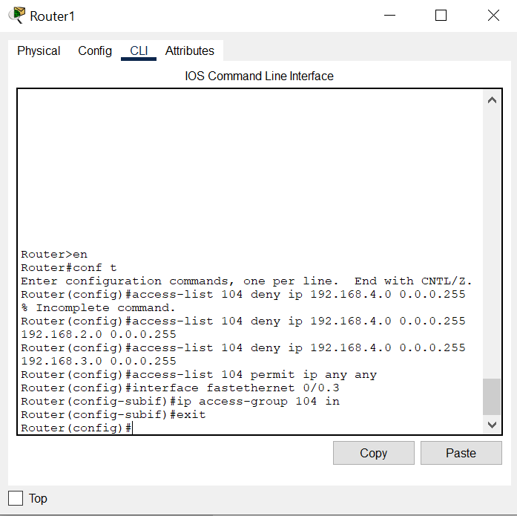B-the Other that the guest users should not have access to the other department

* enable
* conf t
* access-list 104 deny ip 192.168.4.0 0.0.0.255 192.168.2.0 0.0.0.255
* access-list 104 deny ip 192.168.4.0 0.0.0.255 192.168.3.0 0.0.0.255
* access-list 104 permit ip any any
* # Allows all instead of accessing another department
* interface fastethernet 0/0.3
* ip access-group 104 in or ip access-group 104 inbound
* exit



Here we prevent the access from the guest network to the airport authority and the Flight service Providers Network



For the internet connection and any connection rather than accessing the Airport Authority and Flight service Providers Allow it.



This means that the access control list should be applied to the Guest VLAN that its interface is 0/0.3 on the router inbound.

B-The Flight Service Provider only access the server that is responsible to handle management control in the Airport Authority and should not have access to other devices within the VLAN.

Firstly, we set an IP address Statically for the server that the VLAN 3 has access to

Put the IP address for the server to be

192.168.2.2 #based on the VLAN that the server belongs to

255.255.255.0 #for the subnet mask

192.168.2.1 #for the default gateway

* access-list 105 permit ip 192.168.3.0 0.0.0.255 host
* 192.168.2.2 #IP address for the Server not the DHCP the other
* in which the IP address should be assigned statically
* access-list 105 deny ip 192.168.3.0 0.0.0.255 192.168.2.0 0.0.0.255
* access-list permit ip any any
* int fa0/0.2
* 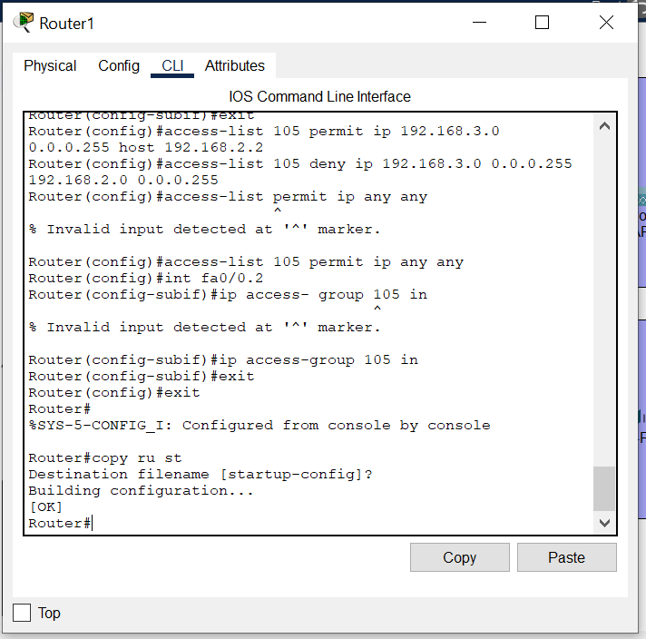ip access-group 105 inbound
* exit
* exit
* copy ru st



Only allow the Flight Service Providers to access in Airport Authority The server and deny any other access.



For the internet connection and any connection rather than accessing the Airport Authority and Flight service Providers Allow it.



This means that the access control list should be applied to the Flight and Service Providers VLAN that its interface is 0/0.2 on the router inbound.

10-Switch Configuration:

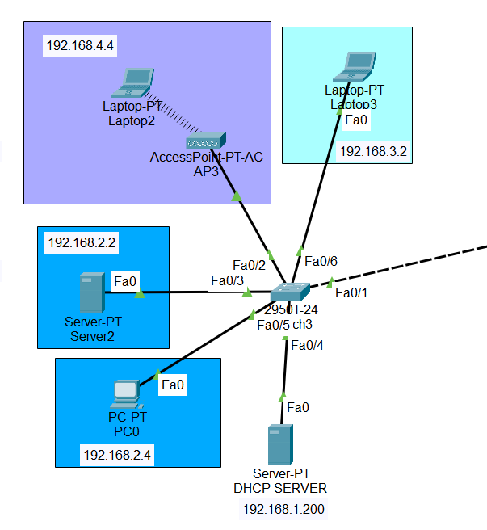We specified for each switch the ports that the vlan devices are connected to whether it’s a access port or trunk port

1. The Left Switch

|  |  |
| --- | --- |
| Fa0/1 | Trunk Port |
| Fa0/6 | Access port |
| Fa0/2 | Access port |
| Fa0/3 | Access port |
| Fa0/5 | Access port |

1-fa0/0

* int fa0/1
* switchport mode trunk
* switchport trunk allowed vlan all
* 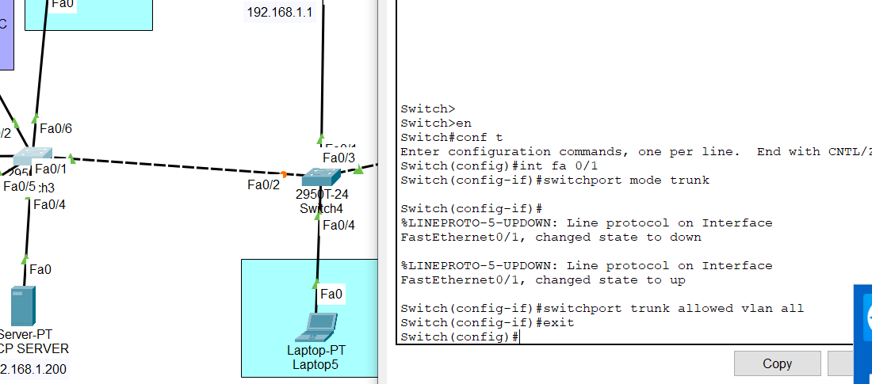exit



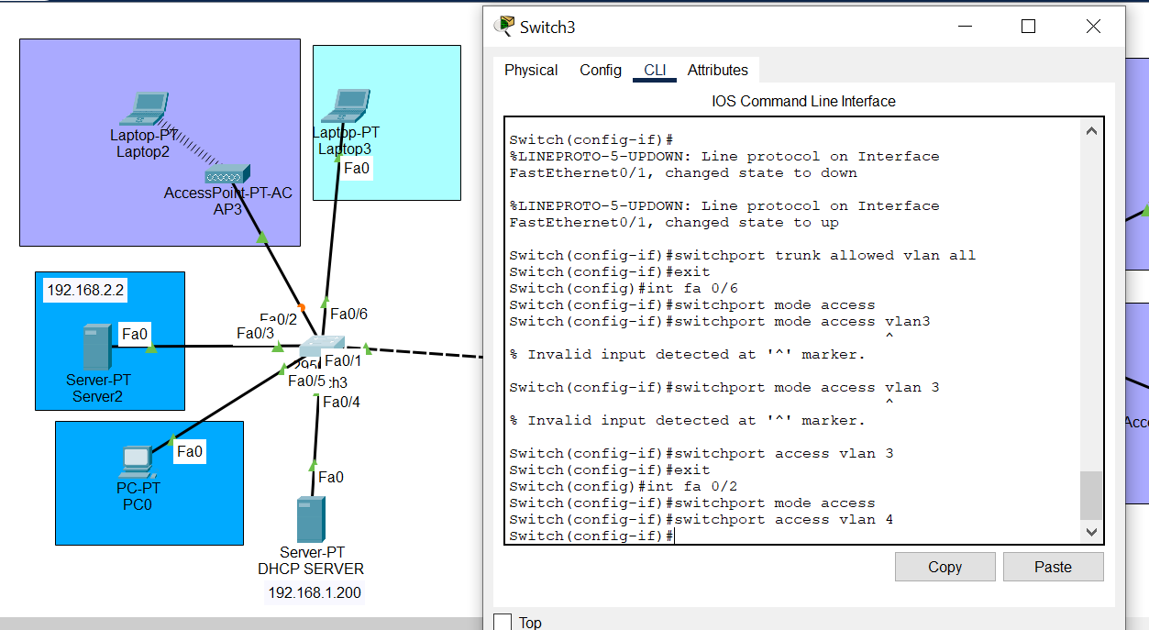

2-fa0/6

* Int fa0/6
* Switchport mode access
* Switchport access vlan 3



* exit



3-fa0/2

* Int fa0/2
* Switchport mode access



* Switchport access vlan 4
* exit

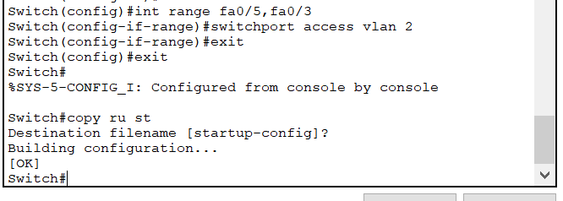4-fa0/5 and fa0/3



* int range fa0/5, fa0/3



* switchport access vlan 2



* exit twice
* copy ru st



|  |  |
| --- | --- |
| int fa0/1 | Trunk port |
| int fa0/3 | Trunk port |
| int fa0/2 | Trunk port |
| int fa0/4 | Access port |

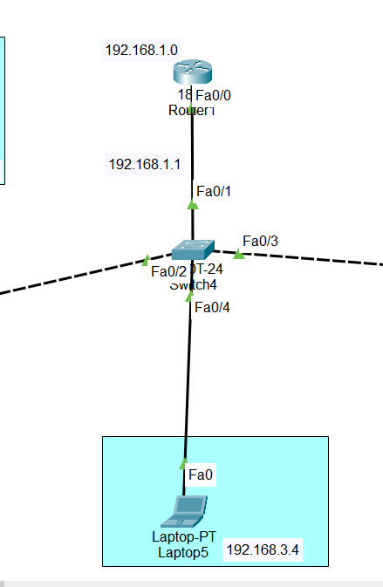

B-The Middle Switch

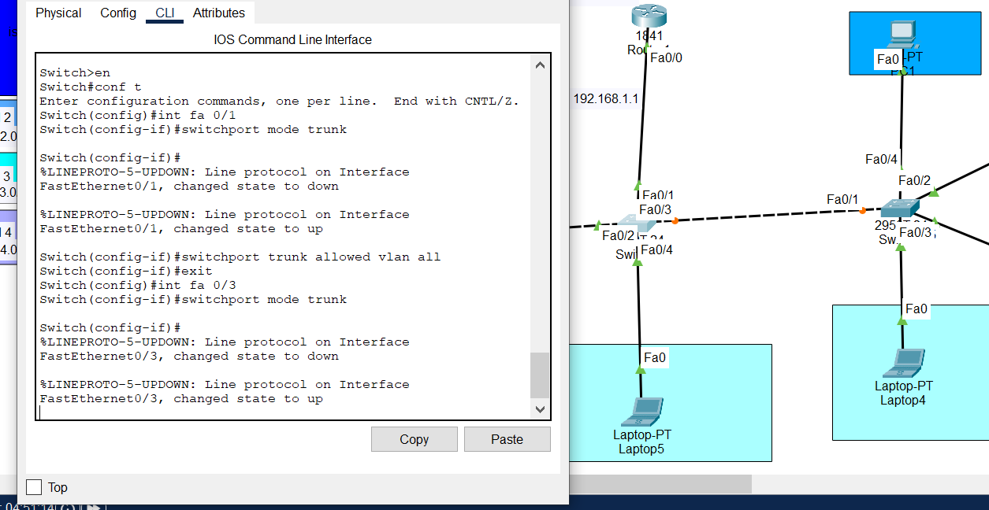



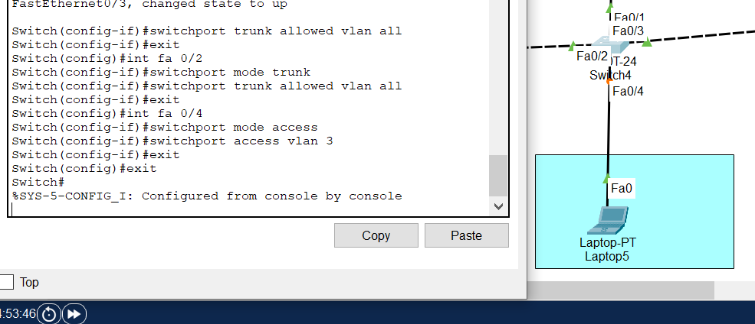

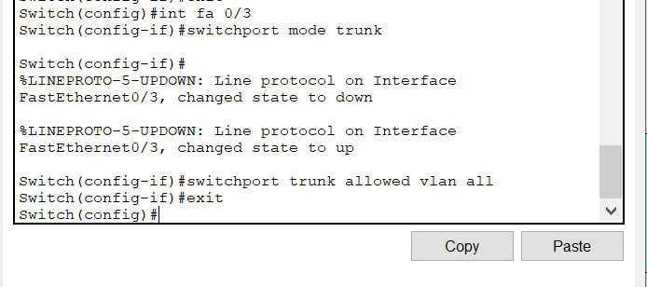



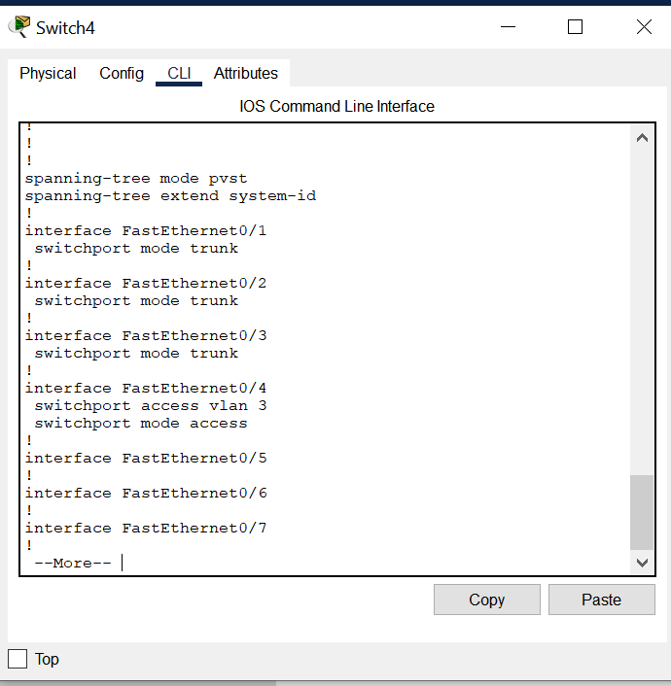

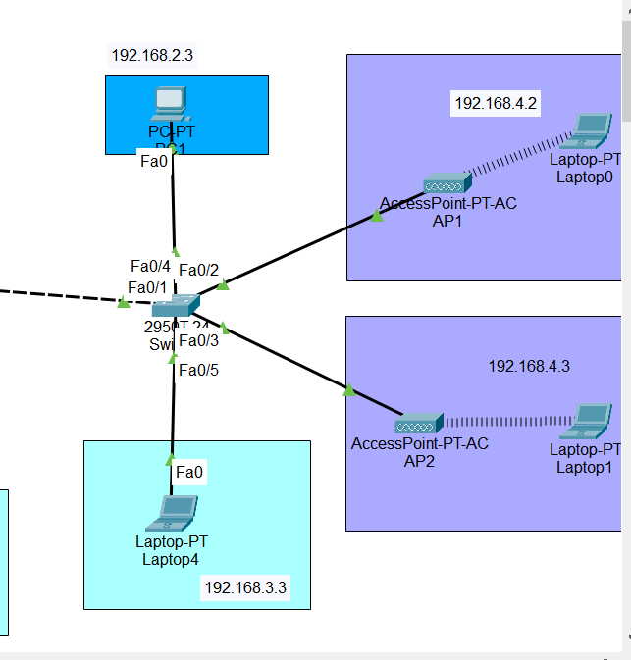

C-The Right Switch

|  |  |
| --- | --- |
| fa0/1 | Trunk port |
| fa0/4 | Access port |
| fa0/2 | Access port |
| fa0/3 | Access port |
| fa0/5 | Access port |

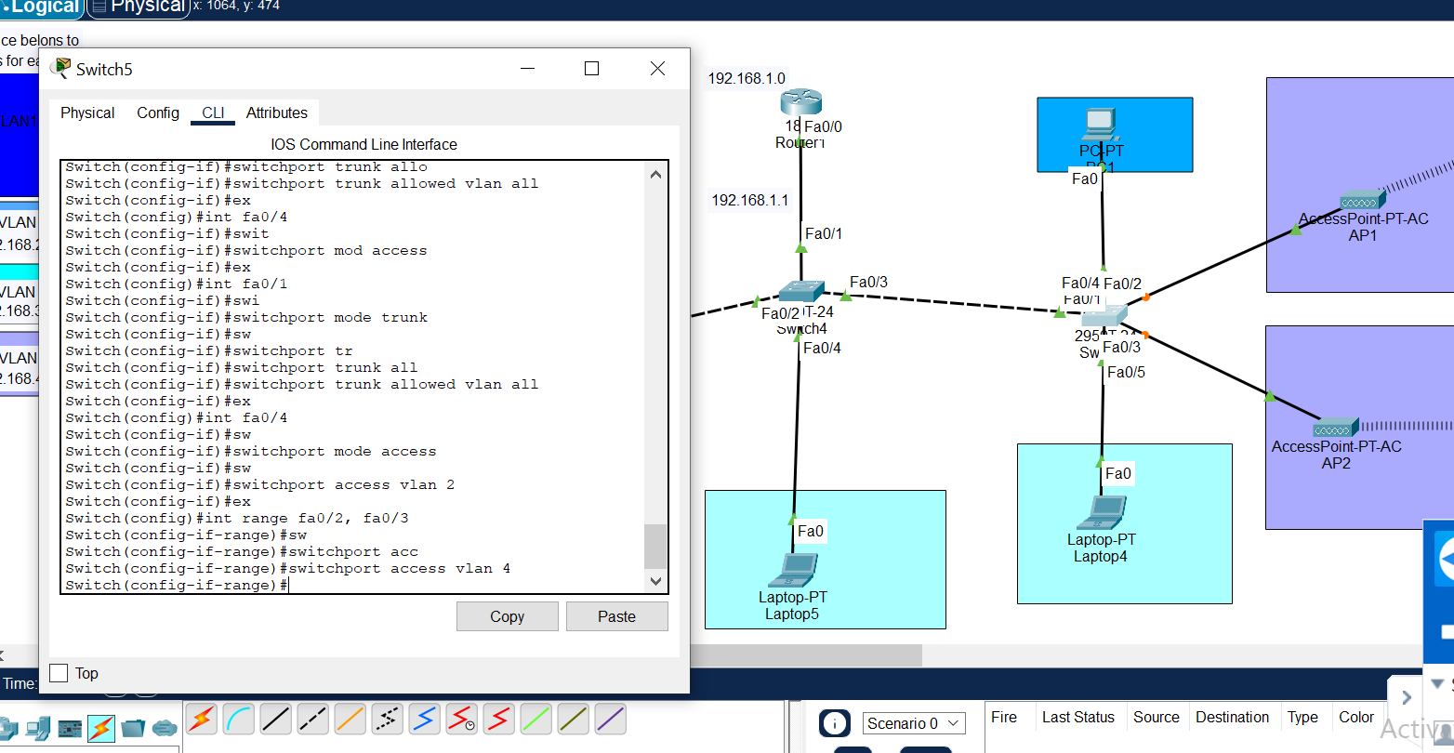



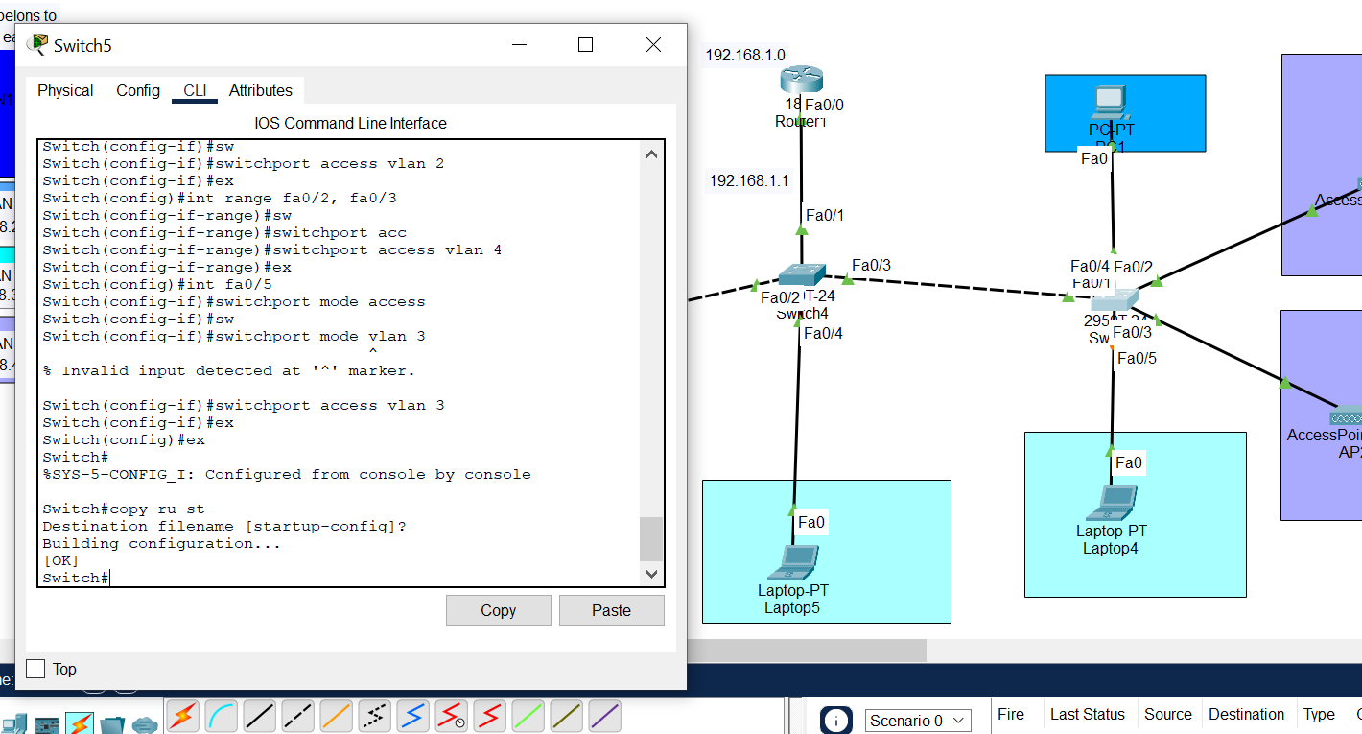



**Conclusions:**

1-testing the restriction done by the Access control list by Ping command line.

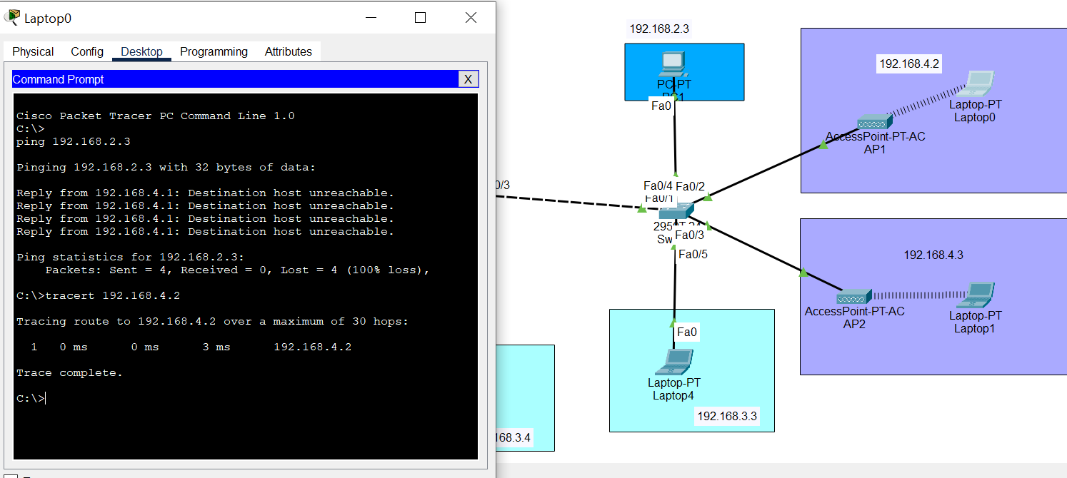We test the Access control list and it is made correctly

The guests are not allowed to access any other department and that what is shown that the destination is unreachable which is a PC that is related to VLAN 2 which the guests department are not allowed to access it and if we apply the tracert we can see that the message only reaches the interface

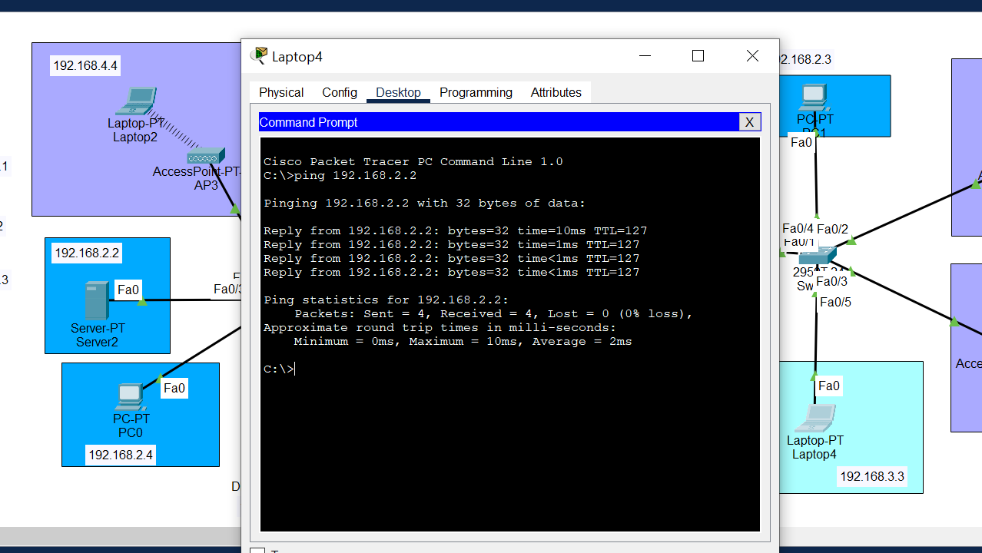Any of Laptops only allowed to access the Airport server to handle management control and not any other

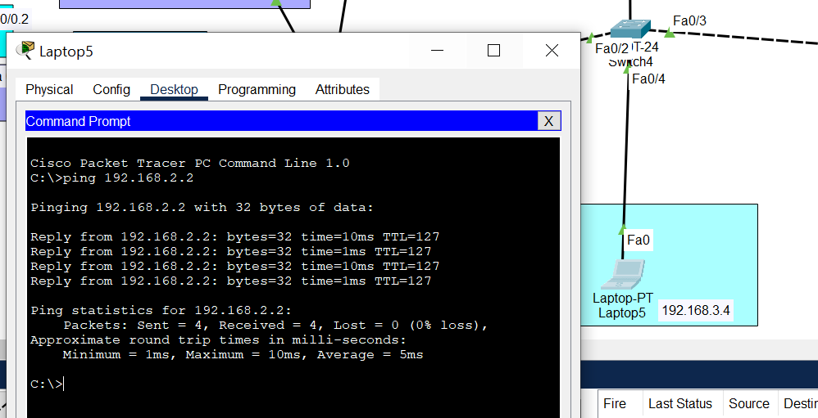

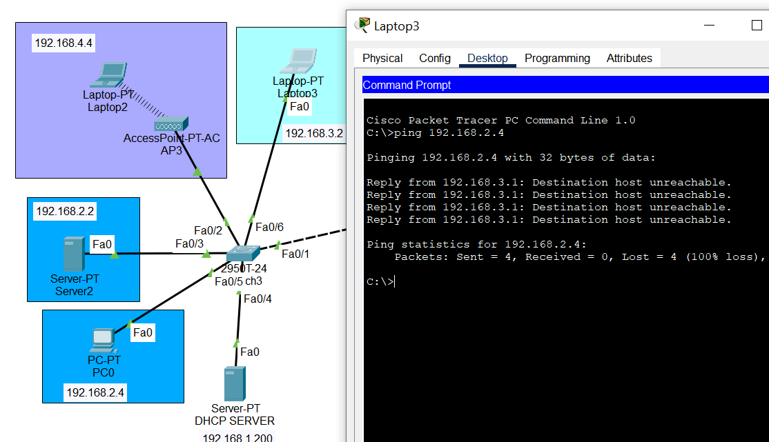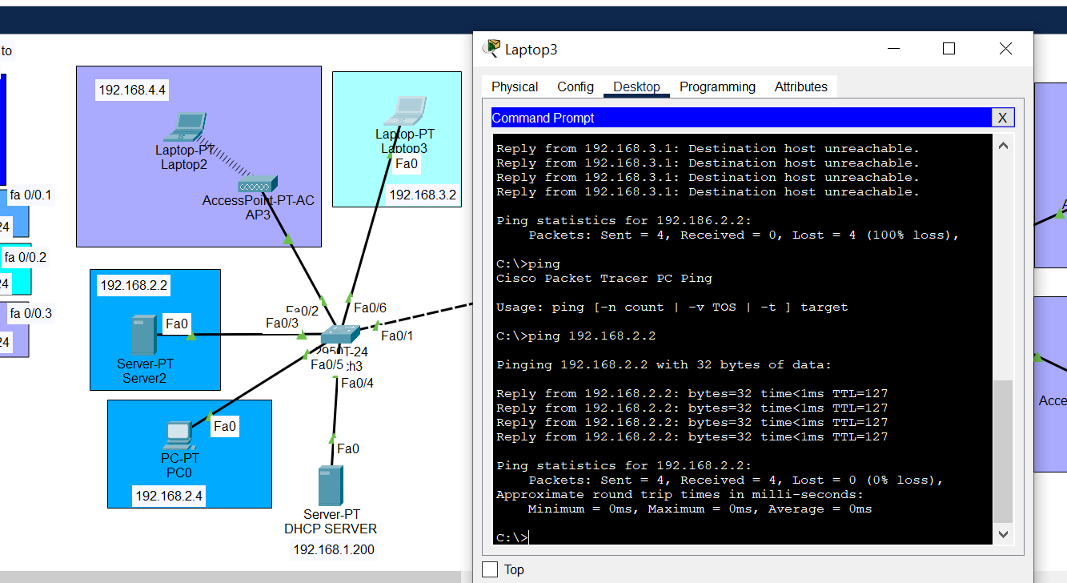But if we try to ping to guest device or other airport PC should return destination unreachable

As shown here we try to ping from device that belongs to VLAN 3 to other in VLAN 2 which they are restricted to access. The same should be applied on the guest’s department

2-testing the restriction done by the Access control list by PDU command line.

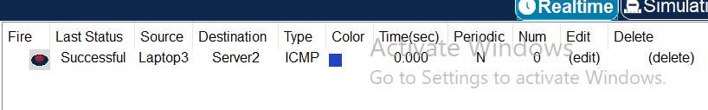

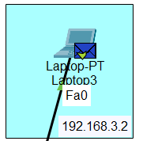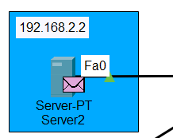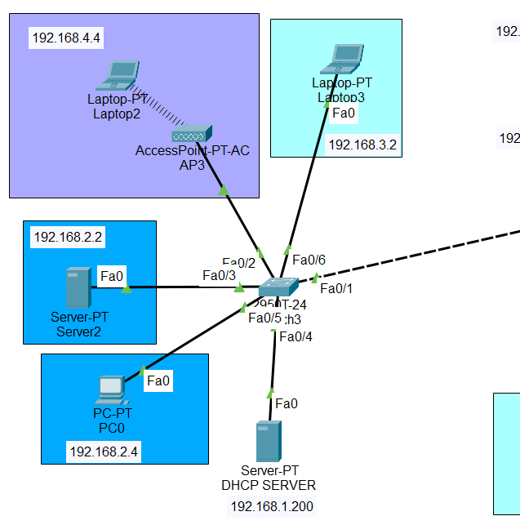

Source. 🡪 Destination.

**Appendix and References:**

* <https://villman.com/Product-Detail/linksys_WPC300N>
* <https://techhub.hpe.com/eginfolib/networking/docs/switches/WB/15-18/5998-8162_wb_2920_mcg/content/ch11s09.html>
* <https://www.accessagility.com/blog/how-to-estimate-number-of-access-points-needed>
* Leen Abdallah 20200512
* Islam Abukaraki 20210627
* Karim abu alinin 20210492
* Sara Mansour 20200628